**M.I.T. Practical Exam**

**U19CS012**

**1.** Write a 8086 Program to Implement the strcpy function:

void strcpy(char *src, char * dest, unsigned char n)

Use src and dest strings as 16-bit addresses, and n as a 8-bit number.

If the length of src string is less than n, the remainder of the destination string will be padded with nulls.

TASM Code:

*; 5. Write a Program to Implement strcpy Function*

.model small

.stack 100

.8086

.data

*; 'n' in the Question*

len db 05h  *; 1Fh = 31 characters (Length of String to be copied)*

*; Source*

str1 db "MICROPROCESSOR AND INTERFACING$"

*; Destination*

str2 db "$$$$$$$$$$$$$$$$$$$$$$$$$$$$$$$$"

.code

*mov* ax,@data

*mov* ds,ax

*mov* es,ax

*mov* ch,00h

*mov* cl,len  *; Initialize Counter*

*; Initialize [SI] & [DI]*

*mov* si,offset str1

*mov* di,offset str2

*; Clear Direction Flag*

*cld*

up: *movsb*

*loop* up

*; Print the Answer*

*mov* ah,09h

*mov* dx,offset str2

*int* 21h

*mov* ax,4c00h

*int* 21h

end

**Input:**

Source String: MICROPROCESSOR AND INTERFACING & n = 5

**Output:**

MICRO

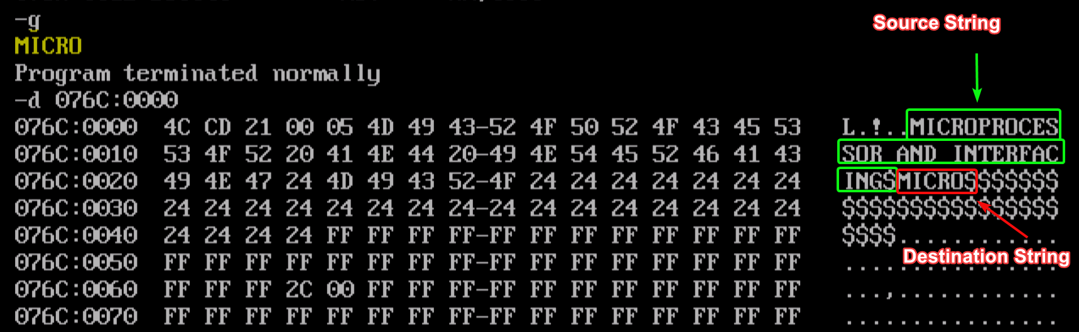

**USER INPUT PROGRAM:**

TASM Code:

*; 2. Write a Program to Implement strcpy Function*

.model small

.stack 100

.8086

.data

*;PRINT MACRO*

print macro msg

*mov* ah,09h

*mov* dx,offset msg

*int* 21h

endm

*; READ MACRO*

read macro str

print msg4

*mov* ah,01h

*int* 21h

*sub* al,'0'

*mov* len1,al

*mov* cl,al

*mov* ch,00h

print msg5

print msg1

*mov* si,offset str

nextc: *mov* ah,01h

*int* 21h

*mov* [si],al

*inc* si

*loop* nextc

endm

str1 db "$$$$$$$$$$$$$$$$$$$$$$$$$$$$$$$$$$$$$$$$$$$$$"

msg1 db "Enter String : $"

msg4 db "Enter length : $"

msg2 db "Enter n : $"

msg5 db " $"

len1 db ?

*; 'n' in the Question*

len db 05h  *; 1Fh = 31 characters (Length of String to be copied)*

*; Source*

*; str1 db "MICROPROCESSOR AND INTERFACING$"*

*; Destination*

str2 db "$$$$$$$$$$$$$$$$$$$$$$$$$$$$$$$$"

.code

*mov* ax,@data

*mov* ds,ax

*mov* es,ax

*mov* ch,00h

*; Take String Input*

read str1

print msg5

print msg2

*mov* ah,01h

*int* 21h

*sub* al,'0'

*mov* len,al

*mov* cl,len  *; Initialize Counter*

*; Initialize [SI] & [DI]*

*mov* si,offset str1

*mov* di,offset str2

*; Clear Direction Flag*

*cld*

up: *movsb*

*loop* up

*; Print the Answer*

*mov* ah,09h

*mov* dx,offset str2

*int* 21h

*mov* ax,4c00h

*int* 21h

end

**Input:**

Source String: MICROPRO & n = 9

**Output:**

MICRO



SUBMITTED BY:

BHAGYA VINOD RANA

[***U19CS012***]